Samba is a free and open-source re-implementation of the SMB that allows end users to access files, printers, and other shared resources.

## *Now* [*nstalling Samba*](https://linuxize.com/post/how-to-install-and-configure-samba-on-ubuntu-18-04/#installing-samba-on-ubuntu) *on server*

*apt update*

*apt install samba -y*

*systemctl status nmbd*

## *Now C*[*onfiguring firewall*](https://linuxize.com/post/how-to-install-and-configure-samba-on-ubuntu-18-04/#configuring-firewall)

*ufw allow 'Samba'*

## [*configure Global Samba*](https://linuxize.com/post/how-to-install-and-configure-samba-on-ubuntu-18-04/#configuring-global-samba-options)

vi /etc/samba/smb.conf

*server role = standalone server*

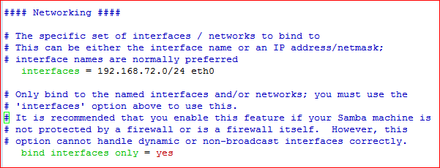

*and save configure file.*

*Check the Samba configuration file for errors by below commands*

*testparm*

***Then restart the Samba service***

*systemctl restart nmbd*

*For easier maintainability and flexibility instead of using the standard home directories (/home/user) all Samba directories and data will be located in the /samba directory.*

***Now create the /samba directory***

*mkdir /samba*

*Set the*[*group ownership*](https://linuxize.com/post/chgrp-command-in-linux/)*to sambashare .This group is created during the Samba installation, later we will add all Samba users to this group.*

*chgrp sambashare /samba*

### *Now C*[*reate Samba Users*](https://linuxize.com/post/how-to-install-and-configure-samba-on-ubuntu-18-04/#creating-samba-users)

*useradd -M -d /samba/josh -s /usr/sbin/nologin -G sambashare josh*

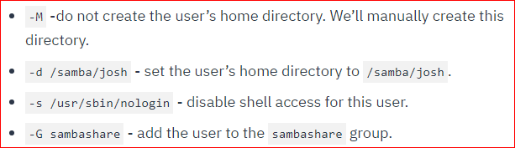

*mkdir /samba/josh*

*chown josh:sambashare /samba/josh*

*chmod 2770 /samba/josh*

*smbpasswd -a josh*

*smbpasswd -e josh*

*let’s create a user and group sadmin .All members of this group will have administrative permissions. Later if you want to grant administrative permissions to another user.*

*useradd -M -d /samba/users -s /usr/sbin/nologin -G sambashare sadmin*

*smbpasswd -a sadmin*

*smbpasswd -e sadmin*

***Now create the Users share directory***

*mkdir /samba/users*

*chown sadmin:sambashare /samba/users*

*chmod 2770 /samba/users*

***Now again Open the Samba configuration file and append the sections***

*vi /etc/samba/smb.conf*

*[users]*

*path = /samba/users*

*browseable = yes*

*read only = no*

*force create mode = 0660*

*force directory mode = 2770*

*valid users = @sambashare @sadmin*

*[josh]*

*path = /samba/josh*

*browseable = no*

*read only = no*

*force create mode = 0660*

*force directory mode = 2770*

*valid users = josh @sadmin*

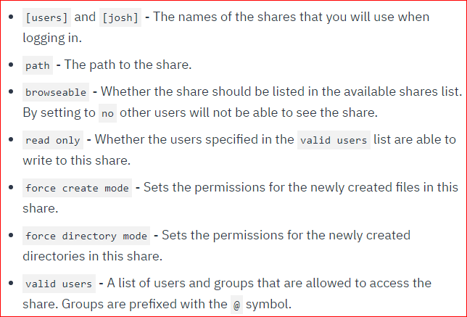

***Now again restart the Samba service***

*systemctl restart nmbd*

### *Now add* [*smb client*](https://linuxize.com/post/how-to-install-and-configure-samba-on-ubuntu-18-04/#using-the-smbclient-client) *for ubuntu*

apt install smbclient

smbclient //192.168.72.80/josh -U josh

### *For Mo*[*unting the Samba share*](https://linuxize.com/post/how-to-install-and-configure-samba-on-ubuntu-18-04/#mounting-the-samba-share) *on ubuntu*

*apt install cifs-utils*

*mkdir /mnt/smbmount*

*mount -t cifs -o username=josh //192.168.72.80/josh /mnt/smbmount*

### *Now add* [*smb client*](https://linuxize.com/post/how-to-install-and-configure-samba-on-ubuntu-18-04/#using-the-smbclient-client) *for centos*

*yum install samba-client*

*mkdir /mnt/smbmount*

*smbclient //192.168.72.80/josh -U josh*

### *For Mo*[*unting the Samba share*](https://linuxize.com/post/how-to-install-and-configure-samba-on-ubuntu-18-04/#mounting-the-samba-share) *on centos*

*yum install cifs-utils*

*mkdir /mnt/smbmount*

*mount -t cifs -o username=josh //192.168.72.80/josh /mnt/smbmount*